**MLOPs with Kubeflow**

Kubeflow is an open-source project that originated from google, it makes deployment of ML model, portable scalable any Kubernetes is run. It has many components that are useful in the machine learning engineering lifecycle of a project.

With **Kubeflow pipeline** or **Kale, The** various stages in a data science workflow can continuously integrated. This stages on a jupyter notebook [ data ingestion, feature engineering, training, testing] can be converted to different microservices running on separate docker containers on Kubernetes and continuously integrated with each other.

This pipeline can be replayed at any time, maintaining standardizations, repeatability. Pipelines could be arranging to train models in parallel and automatically.

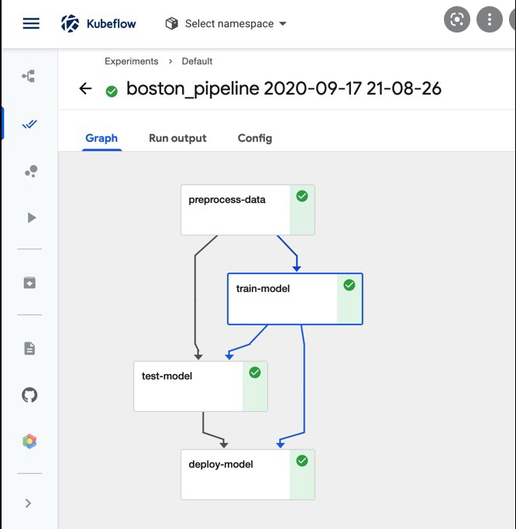

An example of a pipeline.

ML model could be deployed serverless using another Kubeflow components call **kserve ,** this ensure the continuous delivery and monitoring of our inference endpoints. With kserve we could use Alibi detect to detect drifts, outliers and adversary attacks.

**AWS SageMaker**

SageMaker provides an alternative to the open-source libraries where we can bring CI/CD into machine learning workflow. Create, manage and reuse ML workflows. Every step of the workflow is run as a microservice. Using SageMaker Pipelines we could CI/CD all the necessary work steps or SageMakers components used in our projects.

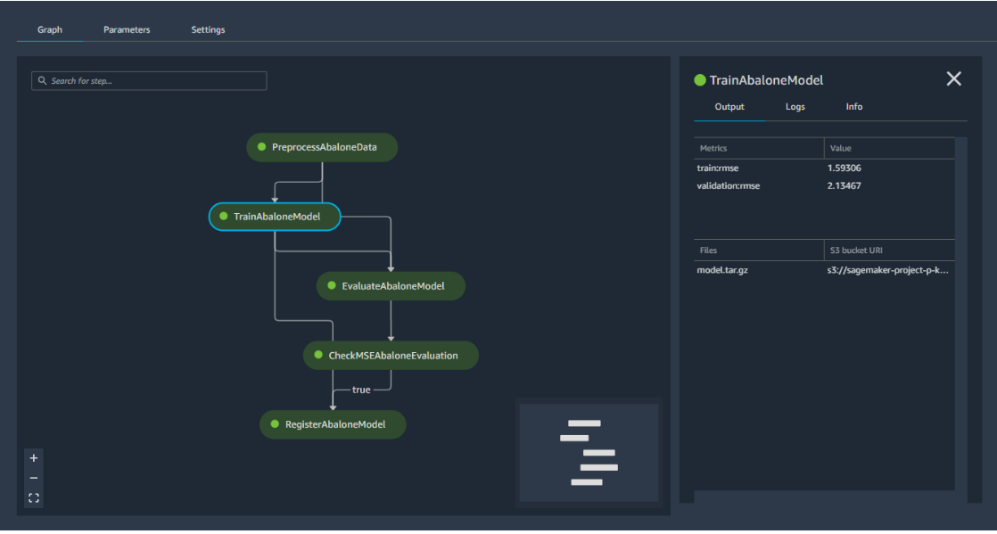

**AWS SageMaker example of ML CI/CD**

AWS also provide IOT services that can be used to onboard sensors, management, collect sensor data send them to the cloud for storage, into Kinesis stream for real time data processing or analysis or into SageMaker for ML model training or to ML endpoint for prediction.

**References**

<https://www.kubeflow.org/docs/components/pipelines/introduction/>

<https://aws.amazon.com/sagemaker/pipelines/>

Hello sir, above is a brief introduction into an opensource MLOPs tool and its AWS equivalence.

Please advice if you will want me to submit a Deep learning project that involves using OpenCV and Keras for classification or image detection.

I am open to answer any question or for further explanation if needed.

Looking forward to hear from you.

Regards

Gerald